**Networking**

Class --

**Lecture --**

**IP Addressing**

**.**



**Lab Objectives:**

* Short description on IP addressing.
* What is IP addressing?
* IP basic information.
* Examples.
* Find the class in binary notation.
* Private IP address ranges.
* Default mask.
* Default subnet mask.
* Default subnet mask patterns.

**ip addressing**

***An Internet Protocol address (IP address) is a numerical label assigned to each device connected to a computer network that uses the Internet Protocol for communication. An IP address serves two principal functions: host or network interface identification and location addressing.***

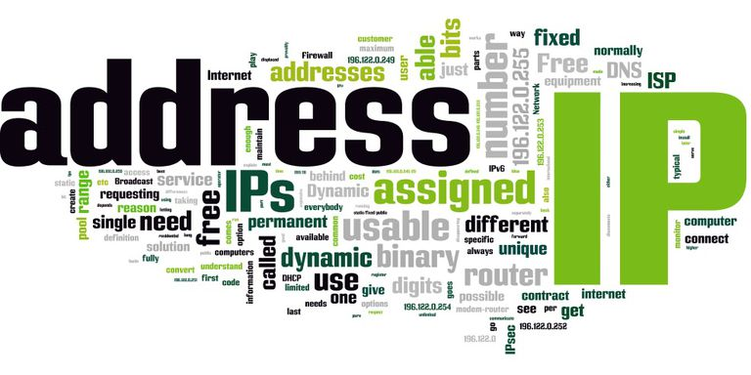



**Example:**

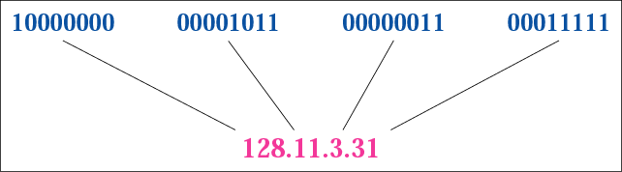

**IP BASICS Information**

***128 192 224 240 248 252 254 255 Accumulated High Order Bit Values\****

***___ ___ ___ ___ ___ ___ ___ ___***

***128 64 32 16 8 4 2 1 Values of Each Bit in an Octet.***

**Finding the class in binary notation**

**PRIVATE IP ADDRESS RANGES**

**Default Mask**

* **Class A default mask is 255.0.0.0**
* **Class B default mask is 255.255.0.0**
* **Class C Default mask 255.255.255.0**

**Default Subnet masks**

|  |  |  |  |  |
| --- | --- | --- | --- | --- |
| ***Class*** | ***1st***  ***Octet*** | ***2nd***  ***Octet*** | ***3rd***  ***Octet*** | ***4th***  ***Octet*** |
| ***A*** | ***N***  ***255*** | ***H***  ***0*** | ***H***  ***0*** | ***H***  ***0*** |
| ***B*** | ***N***  ***255*** | ***N***  ***255*** | ***H***  ***0*** | ***H***  ***0*** |
| ***C*** | ***N***  ***255*** | ***N***  ***255*** | ***N***  ***255*** | ***H***  ***0*** |
| ***The default subnet mask has all ones for each network octet. (255 = 11111111)*** | | | | |

**Default Subnet mask Patterns**



***End Of this slide***